**SEO-2018**

**Q-1[A]ONE MARK:**

1]SERP stand for- Search Engine Results Page

2]QDF stand for- Query Deserves Freshness

3]initially crawler are based on

4]when user view the google search result his eye track create-F shaped pattern

**Q-1[B]TWO MARK:**

1]what is click tracking?

a. Click tracking is a technique used to determine and record what computer users are clicking with their mouse while browsing the Web.

2]explain crawling in detail?

a. Crawling means that Googlebot looks at all the content/code on the page and analyzes it.

A crawler is a program used by [search engines](https://www.searchmetrics.com/glossary/search-engine/) to collect data from the internet. When a crawler visits a [website](https://www.searchmetrics.com/glossary/websites/), it picks over the entire website’s [content](https://www.searchmetrics.com/glossary/page-content/)(i.e. the text) and stores it in a databank. It also stores all the external and internal links to the website. The crawler will visit the stored links at a later point in time, which is how it moves from one website to the next. By this process the crawler captures and [indexes](https://www.searchmetrics.com/glossary/index/) every website that has links to at least one other website.

Q-1[C]THREE MARK:

1]Different types of queries

a. Navigational Search Queries

A navigational query is a search query entered with the intent of finding a particular website or webpage. For example, a user might enter "youtube" into Google's search bar to find the YouTube site rather than entering the URL into a browser's navigation bar or using a bookmark. In fact, “facebook” and “youtube” are the top two searches on Google, and these are both navigational queries.

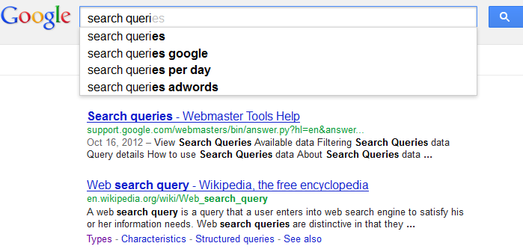

Informational Search Queries

Wikipedia defines informational search queries as “Queries that cover a broad topic (e.g., colorado or trucks) for which there may be thousands of relevant results.” When someone enters an informational search query into Google or another search engine, they’re looking for information – hence the name. They are probably not looking for a specific site, as in a navigational query, and they are not looking to make a commercial transaction. They just want to answer a question or learn how to do something. 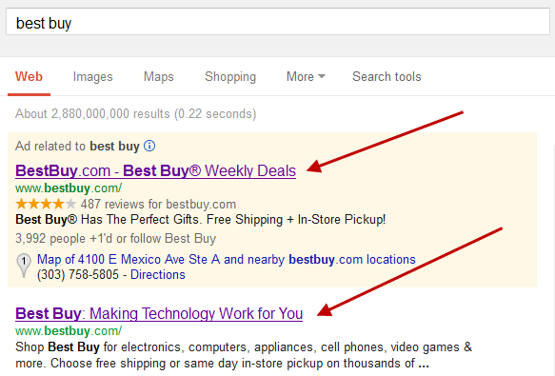

Transactional Search Queries

A transactional search query is a query that indicates an intent to complete a transaction, such as making a purchase. Transactional search queries may include exact brand and product names (like “samsung galaxy s3”) or be generic (like “iced coffee maker”) or actually include terms like “buy,” “purchase,” or “order.” In all of these examples, you can infer that the searcher is considering making a purchase in the near future, if they’re not already pulling out their credit card. In other words, they’re at the business end of the conversion funnel. Many local searches (such as “Denver wine shop”) are transactional as well.

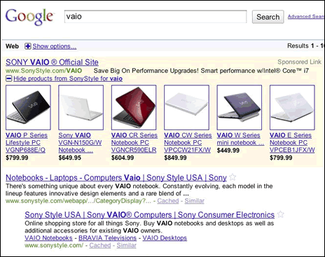

2]explain any three advanced search operator in detail?

a. Advanced search operators are special commands that modify searches and may require additional parameters (such as a domain name). Advanced operators are typically used to narrow searches and drill deeper into results.

II. Advanced Search Operators

intitle: intitle:"tesla vs edison"

Search only in the page's title for a word or phrase. Use exact-match (quotes) for phrases.

allintitle: allintitle: tesla vs edison

Search the page title for every individual term following "allintitle:". Same as multiple intitle:'s.

inurl: tesla announcements inurl:2016

Look for a word or phrase (in quotes) in the document URL. Can combine with other terms.

allinurl: allinurl: amazon field-keywords nikon

Search the URL for every individual term following "allinurl:". Same as multiple inurl:'s.

intext: intext:"orbi vs eero vs google wifi"

Search for a word or phrase (in quotes), but only in the body/document text.

allintext: allintext: orbi eero google wifi

Search the body text for every individual term following "allintext:". Same as multiple intexts:'s.

filetype: "tesla announcements" filetype:pdf

Match only a specific file type. Some examples include PDF, DOC, XLS, PPT, and TXT.

related: related:nytimes.com

Return sites that are related to a target domain. Only works for larger domains.

AROUND(X) tesla AROUND(3) edison

Returns results where the two terms/phrases are within (X) words of each other.

**Q-1[D]FIVE MARK:**

1]vertical search in detail.

a. A vertical search refers to search on a specific topic area or a specific segment of an overall search. An example of a vertical search is Google Image Search. ... Typical vertical search queries include shopping, travel, cars, medical information, and books.

*Vertical search* is the term people sometimes use for specialty or niche search engines that focus on a limited data set (as already mentioned, Google calls them onebox results). Examples of vertical search solutions provided by the major search engines are image, video, news, and blog searches. These may be standard offerings from these vendors, but they are distinct from the engines’ general web search functions.

Vertical search results can provide significant opportunities for the SEO practitioner. High placement in these vertical search results can equate to high placement in the web search results, often above the traditional 10 blue links presented by the search engines.

**Vertical Search from the Major Search Engines**

The big three search engines offer a wide variety of vertical search products. Here is a partial list:

Google

Google Maps, Google Images, Google Product Search, Google Blog Search, Google Video, Google News, Google Custom Search Engine, Google Book Search, Google US Gov’t Search, etc.

Yahoo!

Yahoo! News, Yahoo! Local, Yahoo! Images, Yahoo! Video, Yahoo! Shopping, Yahoo! Audio Search, etc.

Bing

Bing Image, Bing Video, Bing News, Bing Maps, Bing Health, Bing Products, etc.

2]component of SERP page

A. Search Engine Results Pages (SERP) are the pages displayed by search engines in response to a query by a user. The main component of the SERP is the listing of results that are returned by the search engine in response to a keyword query.

The results are of two general types, organic search (i.e., retrieved by the search engine's algorithm) and sponsored search (i.e., advertisements). The results are normally ranked by relevance to the query. Each result displayed on the SERP

normally includes a title, a link that points to the actual page on the Web, and a short description showing where the keywords have matched content within the page for organic results. For sponsored results, the advertiser chooses what to display.

[1Components](https://en.wikipedia.org/wiki/Search_engine_results_page#Components)

* [1.1Search query](https://en.wikipedia.org/wiki/Search_engine_results_page#Search_query)
* [1.2Organic results](https://en.wikipedia.org/wiki/Search_engine_results_page#Organic_results)
* [1.3Sponsored results](https://en.wikipedia.org/wiki/Search_engine_results_page#Sponsored_results)
* [1.4Rich Snippets](https://en.wikipedia.org/wiki/Search_engine_results_page#Rich_Snippets)
* [1.5**Featured Snippets**](https://en.wikipedia.org/wiki/Search_engine_results_page#Featured_Snippets)
* [1.6Knowledge Graph](https://en.wikipedia.org/wiki/Search_engine_results_page#Knowledge_Graph)

**Components**

The organic search results, query, and advertisements are the three main components of the SERP, However, the SERP of major search engines, like Google, Yahoo!, and Bing, may include many different types of enhanced results (organic search, and sponsored) such as rich snippets, images, maps, definitions, answer boxes, videos or suggested search refinements. A recent study revealed that 97% of queries in Google returned at least one rich feature.[2]

The major search engines visually differentiate specific content types such as images, news, and blogs. Many content types have specialized SERP templates and visual enhancements on the first search results page.

🡪Search query

Also known as 'user search string', this is the word or set of words that are typed by the user in the search bar of the search engine. The search box is located on all major search engines like Google, Yahoo, and Bing. Users indicate the topic desired based on the keywords they enter into the search box in the search engine.

In the competition between search engines to draw the attention of more users and advertisers, consumer satisfaction has been a driving force in the evolution of the search algorithm applied to better filter the results by relevancy.

Search queries are no longer successful based upon merely finding words that match purely by spelling. Intent and expectations have to be derived to determine whether the appropriate result is a match based upon the broader meanings drawn from context.

🡪Organic results

Organic SERP listings are the natural listings generated by search engines based on a series of metrics that determine their relevance to the searched term. Webpages that score well on a search engine's algorithmic test show in this list. These algorithms are generally based upon factors such as quality and relevance of the content, expertise, authoritativeness, and trustworthiness of the website and author on a given topic, good user experience and backlinks.[3]

People tend to view the first results on the first page.[4] Each page of search engine results usually contains 10 organic listings (however some results pages may have fewer organic listings). According to a 2019 study,[5] the CTR's for the first page goes as follows:

Position 1: 31.7%

Position 2: 24.7%

Position 3: 18.7%

Position 4: 13.6%

Position 5: 9.5%

Position 6: 6.2%

Position 7: 4.2%

Position 8: 3.1%

Position 9: 3%

Position 10: 3.1%

**Sponsored results**[[edit](https://en.wikipedia.org/w/index.php?title=Search_engine_results_page&action=edit&section=4)]

*Main article:*[*Search engine marketing § Paid inclusion*](https://en.wikipedia.org/wiki/Search_engine_marketing#Paid_inclusion)

Every major search engine with significant market share accepts paid listings. This unique form of search engine advertising guarantees that your site will appear in the top results for the keywords you target. Paid search listings are also called sponsored listings and/or [Pay Per Click (PPC)](https://en.wikipedia.org/wiki/Pay_Per_Click) listings.

**Rich Snippets**[[edit](https://en.wikipedia.org/w/index.php?title=Search_engine_results_page&action=edit&section=5)]

Rich snippets are displayed by [Google](https://en.wikipedia.org/wiki/Google) in the search results pages when a website contains content in structured data markup. Structured data markup helps the [Google algorithm](https://en.wikipedia.org/wiki/Google_Algorithm_updates_in_2017) to index and understand the content better. Google supports rich snippets for the following data types**:**[**[6]**](https://en.wikipedia.org/wiki/Search_engine_results_page#cite_note-6)

* Product – Information about a product, including price, availability, and review ratings.
* Recipe – Recipes that can be displayed in web searches and Recipe View.
* Review – A review of an item such as a restaurant, movie, or store.
* Event – An organized event, such as musical concerts or art festivals, that people may attend at a particular time and place.
* Software Application – Information about a software app, including its URL, review ratings, and price.
* Video – An online video, including a description and thumbnail and It shows the three resources of answers image, content and URL in one box.
* News article – A news article, including the headline, images, and publisher info.
* Science datasets
* Job-related content

**Featured Snippets**[[edit](https://en.wikipedia.org/w/index.php?title=Search_engine_results_page&action=edit&section=6)]

Featured Snippet is a summary of an answer to user's query. This snippet appears at the top of organic results on **SERP**. Google supports the following types of featured snippets:[[7]](https://en.wikipedia.org/wiki/Search_engine_results_page#cite_note-7)

* Paragraph snippet – Paragraph clearly comes from a longer list it gives brief answers through relevant keywords.
* Numbered / Bulleted – List of items that a user is searching to find those list or bulleted items are represented by Google through user's query.
* Table snippet – Answers are displayed based on required comparison. Google extract the data from content and reformat it into table snippet.
* Video – Google can show an exact video snippet from YouTube that corresponds to the search query and users can play it in the SERP.
* Combination of the aforementioned

**Knowledge Graph**[[edit](https://en.wikipedia.org/w/index.php?title=Search_engine_results_page&action=edit&section=7)]

Search engines like Google or Bing have started to expand their data into [Encyclopedia](https://en.wikipedia.org/wiki/Encyclopedia) and other rich sources of information.

Google for example calls this sort of information "[Knowledge Graph](https://en.wikipedia.org/wiki/Knowledge_Graph)", if a search query matches it will display an additional sub-window on right hand side with information from its sources.[[8]](https://en.wikipedia.org/wiki/Search_engine_results_page#cite_note-8)[[9]](https://en.wikipedia.org/wiki/Search_engine_results_page#cite_note-9)

Information about the product (example Nike), hotels, events, flights, places, businesses, people, books and movies, countries, sports groups, architecture and more can be obtained that way.

**Q-2[A]ONE MARK:**

1]PPC stand for- pay-per-click

2]ROI stand for-return on investment.

3]what is log file tracking?

a. A **log file** is a actually a **file** output made from a web server containing 'hits' or record of all requests that the server has received. Data are stored and deliver details about the time and date in which the request was made, the URL requested, the user agent, the request ID address and other ones.

4]what is page load time?

a.  Load time which defines how long does it take for an entire page to display in a browser's window.

**Q-2[B]TWO MARK:**

1]what are the strategic goals seo?

a.Visibility

The first goal SEO consultants can fulfill is increased online brand visibility. Consumers assume that top placement in the search rankings is a “stamp of approval” for the brand. While we know that this is not always the case, many searchers interpret high rank as a brand endorsement.

Making sure that you have a plan of action to increase the organic search exposure for branded keywords is extremely important. Just to make sure we are all on the same page about branded terms, here is a good definition: branded keywords are the search words or phrases that include the brand name or a variation of the brand name. While branded terms typically drive traffic from people who have already heard of your company, they are still important.

The goal of SEO is not just to protect your brand; it’s also about increasing the visibility of your brand within your targeted niche. As you can probably guess, this is where non-branded terms are essential. While I won’t get into [keyword research](https://searchengineland.com/library/search-engine-optimization/seo-keyword-research), you do want to make sure that your target terms are specific to your core business.

**Tracking visibility**

Tracking your target keyword terms can deliver a ton of insight. While I do caution you not to obsess over rankings, it is important to know where you stand and which direction you’re moving. Being able to send these reports to your management team or clients can also help build trust.

To get started, make sure you have a list of your branded and non-branded terms that you want to track. There are a number of tools you can use to track your ranking, some free and some paid. As you can guess, the free tools will have some restrictions but can still get the job done.

One great free option is SERPs’ Rank Checker. They allow you to track by geolocation, search engine and device. The free version won’t let you keep a record of position history, so it will be important for you to save all your data in a spreadsheet for reporting over time.

Using a paid tool gives you a lot more flexibility as well as ranking history. Many enterprise- and professional-level SEO tools do have rank trackers built in and allow you to see you ranking history over time. The benefit of these tools is that you have all your data in one location, and you can report the success of your SEO efforts when it comes to visibility much more efficiently.

Website traffic

While “build it and they will come” sounds like a good mantra, the fact is, it’s dead wrong. Just having a website is not enough. That’s like opening a business on a road with little to no traffic and expecting people will just “find you.” Great SEO can deliver targeted, relevant traffic to your website.

It’s the goal of an SEO strategy to bring new prospects to your website — people who would otherwise never know that you even existed. Experienced search professionals will take the time to understand not just your products, services and business goals, but also the needs of the audience you are trying to reach.

I’ve worked with some companies that had done a less-than-adequate job of telling the population about what they provide. By aligning their on-site and off-site SEO activities to promote their services to their targeted audiences, we were able to bring prospects to their site who never knew they provided those services.

**Tracking traffic**

While traffic is just part of the sales and growth equation, it plays a significant role. Many site owners need reminders of the power of traffic. Giving your manager or client updates on their traffic and helping them understand its role in the overall success of sales and marketing can be difficult, but it’s not impossible.

[Google Analytics](https://searchengineland.com/library/google/google-analytics) and Data Studio are great free tools that can help you monitor and report the success of your SEO campaigns to your clients. When reporting on traffic, make sure you don’t overwhelm them with data. Never report more than seven KPIs — any more than that, and they will get overlooked. Here are a few KPIs we cover in our SEO success reports:

* Sessions.
* Users.
* Page views.
* Pages per session.
* Average session duration.
* Bounce rate.

Delivering ROI

Companies that invest in marketing demand ROI. If they can’t see or validate the return on their investment, they will stop investing. But determining ROI is not so cut-and-dried. Each business has its own set of goals, and all SEO activities need to align with them.

Some of the goals that typically cross all businesses are sales and leads. Being able to show how your SEO efforts have played a role in these requires appropriate tracking. Again, Google Analytics can be an excellent tool for this. Using the “goals” function, you can measure the impact of your efforts and then report your findings using Data Studio.

The goal of SEO is not just to drive traffic; it is to drive targeted traffic that takes action. When sales numbers go up, people tend to forget how they got there. This is why being able to show your results will help you continue to receive buy-in.

SEO can provide a number of benefits to site owners and organizations. From generating more buzz around your brand and growing your online visibility to increasing your traffic and driving conversions, search is one of the most cost-effective marketing tactics you can use today. By working on delivering on the goals above, you’ll be able to prove your worth and help those you work with (and for) understand the power of search.

2]what is temporary redirects?

a. A 302 redirect lets search engines know that a website or page has been moved *temporarily*.

You would use this type of redirect if you want to send users to a new site or page for a short period of time, such as when you’re redesigning or updating your website.

**Q-2[D]THREE MARK:**

1]explain business factor their affect on seo plan

a. . There are many reasons why business can affect SEO and they are:

1.Target Market

Who do you want to sell to? Is the market specific like teenage boys or more broad like women 25+? Knowing the target market ahead of time, will allow for the individual pages to be optimised for the strongest keywords.

2.Revenue

What is the purpose of the site? Is it to produce content for visitors to read? Are you selling something?

3.Competitor Strategies

Who are your biggest competitors and how do you intend to best them? Are you trying to capitalise on a niche corner of the market or are you already an established brand hoping to destroy all opposition?

4.Budget

We have already covered that a perfectly implemented SEO strategy stands to deliver incredible ROI. As a result, early implementation is invaluable for a fledgling business.

5.The Minds of Your Customers

What do the members of your market think when expressing interest in your market? Knowing the most popular search queries of your customers and implementing them into the website is SEO 101.

6.Goals for Branding

Are there key phrases or terms you need to own?

2]SWOT analysis in details

a. SWOT stands for Strengths, Weaknesses, Opportunities, and Threats.

SWOT analysis (or SWOT matrix) is a strategic planning technique used to help a person or organization identify strengths, weaknesses, opportunities, and threats related to business competition or project planning.[1] It is designed for use in the preliminary stages of decision-making processes and can be used as a tool for evaluation of the strategic position of a city or organization.

The name is an acronym for the four parameters the technique examines:

Strengths: characteristics of the business or project that give it an advantage over others.

Weaknesses: characteristics of the business that place the business or project at a disadvantage relative to others.

Opportunities: elements in the environment that the business or project could exploit to its advantage.

Threats: elements in the environment that could cause trouble for the business or project.

**Q-2[D]FIVE MARK:**

1]structural decision in detail

a. **Structural Decisions**

One of the most basic decisions to make about a website concerns internal linking and navigational structures, which are generally mapped out in a site architecture document. What pages are linked to from the home page? What pages are used as top-level categories that then lead site visitors to other related pages? Do pages that are relevant to each other link to each other? There are many, many aspects to determining a linking structure for a site, and it is a major usability issue because visitors make use of the links to surf around your website. For search engines, the navigation structure helps their crawlers determine what pages you consider the most important on your site, and it helps them establish the relevance of the pages on your site to specific topics.

**TARGET KEYWORDS**

As we will discuss in [Chapter 5](https://learning.oreilly.com/library/view/the-art-of/9781449324865/ch05.html), keyword research is a critical component of SEO. What search terms do people use when searching for products or services similar to yours? How do those terms match up with your site hierarchy? Ultimately, the logical structure of your pages should match up with the way users think about products and services like yours. [Figure 4-2](https://learning.oreilly.com/library/view/the-art-of/9781449324865/ch04s03.html#example_of_a_well-thought-out_site_hiera) shows how this is done on the Amazon site.

**CROSS-LINK RELEVANT CONTENT**

Linking between articles that cover related material can be very powerful. It helps the search engine ascertain with greater confidence how relevant a web page is to a particular topic. This can be extremely difficult to do well if you have a massive ecommerce site, but Amazon solves the problem very well, as shown in [Figure 4-3](https://learning.oreilly.com/library/view/the-art-of/9781449324865/ch04s03.html#product_cross-linking_on_amazon).

**USE ANCHOR TEXT**

Anchor text is one of the golden opportunities of internal linking. As an SEO practitioner, you need to have in your plan from the very beginning a way to use keyword-rich anchor text in your internal links. Avoid using text such as “More” or “Click here,” and make sure the technical and creative teams understand this. You also need to invest time in preparing an anchor text strategy for the site.

**USE BREADCRUMB NAVIGATION**

Breadcrumb navigation is a way to show the user where he is in the navigation hierarchy.

**MINIMIZE LINK DEPTH**

Search engines (and users) look to the site architecture for clues as to what pages are most important. A key factor is how many clicks from the home page it takes to reach a page. A page that is only one click from the home page is clearly important. A page that is five clicks away is not nearly as influential. In fact, the search engine spider may never even find such a page (depending in part on the site’s link authority).

Standard SEO advice is to keep the site architecture as flat as possible, to minimize clicks from the home page to important content. Do not go off the deep end, though; too many links on a page are not good for search engines either (a standard recommendation is not to exceed 100 links from a web page; we will cover this in more detail in [Chapter 6](https://learning.oreilly.com/library/view/the-art-of/9781449324865/ch06.html)). The bottom line is that you need to plan out a site structure that is as flat as you can reasonably make it without compromising the user experience.

In this and the preceding sections, we outlined common structural decisions that you need to make prior to beginning your SEO project. There are other considerations, such as how you might be able to make your efforts scale across a very large site (thousands of pages or more). In such a situation, you cannot feasibly review every page one by one.

2]explain different element of seo audit plan

a.**1. Discoverability**

You want to make sure you have a nice, accessible site for search engines crawlers. This means that a site’s content is available in HTML form, or relatively easy to interpret JavaScript. For example, Adobe Flash files are difficult for Google to extract information from, though Google has said that it can extract *some* information.

Part of having an accessible website for search engines and users is the information architecture on a site—how the content and “files” are organized. This helps search engines make connections between concepts and helps users find what they are looking for with ease.

To think about how to do this well, it’s helpful to compare it to how you deal with paper files in your office:  
  
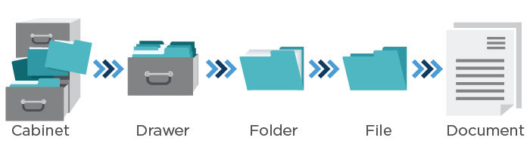  
  
A well-organized site hierarchy also helps the search engines better understand the semantic relationships between the sections of the site. This gets reinforced by other key site elements like XML Sitemaps, HTML site maps, and breadcrumbs, all of which can help neatly tie the overall site structure together.

[Tweet “Well-structured site architecture helps search engines understand your site. Learn SEO audits at”]

**2. Basic Health Checks**

Basic health checks can provide quick red flags when a problem emerges, so it’s good to do these on a regular basis (even more often than you do a full audit). Here are four steps you can take to get a diagnosis of how a website is doing in the search engine results:

1. Ensure Google Search Console and Bing Webmaster Tools accounts have been verified for the domain (and any subdomains, for mobile or other content areas). Google and Bing also offer site owner validation that allows you to see how the search engines view a site. Then, check these on a regular basis to see if you’ve received any messages from the search engine. If the site has been hit by a penalty from Google, you’ll see a message, and you’ll want to get to that as soon as possible. They’ll also let you know if the site has been hacked.
2. Find out how many of a website’s pages appear to be in the search index. You can do this by going to Google Search Console as follows: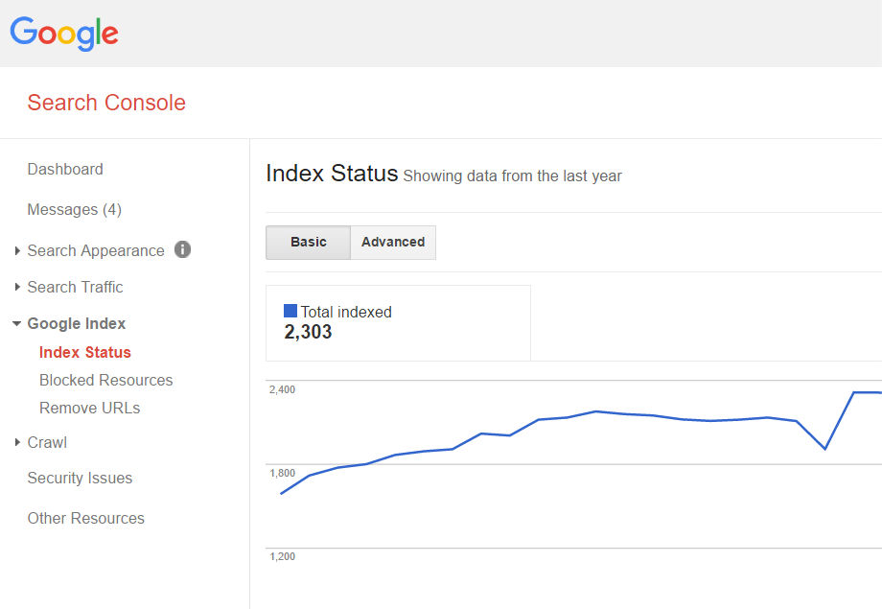Has this number changed in an unexpected way since you last saw it? Sudden changes could indicate a problem. Also, does it seem like it matches up approximately with the number of pages you think exist?I wouldn’t worry about it being 20 percent smaller or larger than you think, but if it’s double, triple or more, or only about 20 percent of the site, you probably want to understand why.
3. Go into Google Search Console to make sure the cached versions of a website’s pages look the same as the live versions. Below you can see an example of this using a page on the Perficient Digital web site.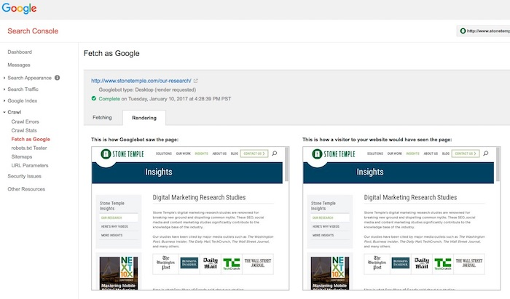
4. Test searches of the website’s branded terms to make sure the site is ranking for them. If not, it could indicate a penalty. Check the Google Search Console/Bing Webmaster Tools accounts to see if there are any identifiable penalties.

[Tweet “Learn how to do a basic site health check as part of an #SEO audit.”]

**3. Keyword Health Checks**

You’ll want to perform an analysis of the keywords you’re targeting on the site. This can be accomplished by many of the various SEO tools available. One thing to look for in general is if more than one page is targeting or showing up in the search results for the same keyword (aka “keyword cannibalization”).  
  
You can also use Search Console to see what keywords are driving traffic to the site. If you see critical keywords that used to receive traffic are no longer working (the rankings dropped) that could be a sign of a problem.

On the positive site of the ledger, look for “striking distance” keywords, those that rank in positions from five to 20 or so. These might be keywords where some level of optimization could move them up in the rankings. If you can move from position five to three or 15 to eight on a major keyword, that could result in valuable extra traffic and provide reasonably high ROI for the effort involved.

[Tweet “For great #SEO opportunities, look for striking distance keywords. Learn more at”]

**4. Content Review**

Here, we’re looking for a couple things:

1. **Content depth, quality, and optimization:** Do the pages have enough quality information to satisfy a searcher? You want to make sure the number of pages with little or “thin” content is small compared to those with substantial content. There are many ways to generate thin content.One example is a site that has image galleries with separate URLs for each image. Another is a site with city pages related to their business in hundreds, or thousands, of locations where they don’t do business, and where there is really no local aspect to the product or services they are offering on their site. Google has no interested in indexing all those versions, so you shouldn’t be asking them to do so!This is often one of the most underappreciated aspects of SEO. At Perficient Digital, we’ve taken existing content on pages and rewritten it, and seen substantial traffic lifts. In more than one case, we’ve done this on more than 100 pages of a site and seen traffic gains of more than 150 percent!
2. **Duplicate content:** A lot of websites have duplicate content without even realizing it. One of the first things to check is that the “www” version of the site and the “non-www” version do not exist at the same time (do they both resolve?). This can also happen with “http” and “https” versions of a site. Pick one version and 301 redirect the other to it. You can also set the [preferred domain in Google Search Console](https://support.google.com/webmasters/answer/44231?hl=en) (but still do the redirects even if you do this).

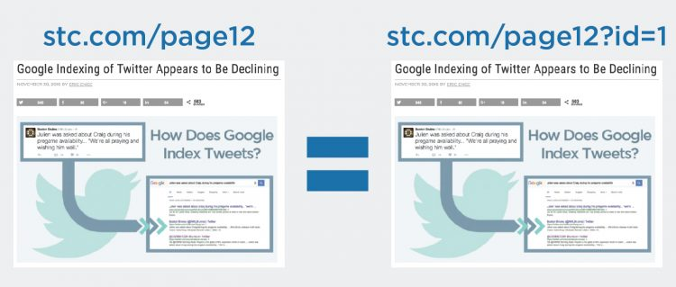

1. **Ad Density:** Review the pages of your site to assess if you’re overdoing it with your advertising efforts. Google doesn’t like sites that have too many ads above the fold. A best practice to keep in mind is that the user should be able to get a substantial amount of the content they were looking for above the fold.

[Tweet “A thorough content review is an essential part of any #SEO audit. Learn more at”]

**5. URL Names**

Website URLs should be “clean,” short and descriptive of the main idea of the page *and* indicate where a person is at in the website. So, make sure this is part of the SEO audit. Ensuring URLs are constructed well is helpful for both website users and search engines to orient themselves.

For example: www.site.com/outerwear/mens/hats

[](https://blogs.perficient.com/covid-19-digital-insight-for-enterprise-action/)

[COVID-19: Digital Insights For Enterprise Action](https://blogs.perficient.com/covid-19-digital-insight-for-enterprise-action/)

Access Perficient’s latest insights into how you can leverage digital technologies to not only respond to the pandemic, but drive your operations forward and deliver experiences your customers need.

[**Get Informed**](https://blogs.perficient.com/covid-19-digital-insight-for-enterprise-action/)

[Tweet “URLs should be clean, short, and descriptive of the page main idea. More at”]

It’s a good idea to include the main keyword for the web page in the URL, but never try to keyword-stuff (for example, www.site.com/outerwear/mens/hat-hats-hats-for-men).

Another consideration are URLs that have tracking parameters on them. Please *don’t ever do this* on a website! There are many ways to implement tracking on a site, and using parameters in the URLs is *the worst way* to do this.

If a website is doing this today, you’ll want to go through a project to remove the tracking parameters from the URLs, and switch to some other method for tracking.

On the other hand, perhaps the URLs are only moderately suboptimal, such as this one:  
  
http://www.site.com?category=428&product=80328

In cases like this, I don’t think that changing the URLs is that urgent. I’d wait until you’re in the midst of another larger site project at the same time (like a redesign).

**6. URL Redirects**

It’s a common best practice to ensure that a web page that no longer needs to exist on a website be redirected to the next most relevant live web page using a [301 redirect](https://support.google.com/webmasters/answer/93633?hl=en). There are other redirect types that exist as well, so be sure to understand the various types and how they function before using any of them.

[Tweet “Be sure to redirect pages that no longer need to be indexed in search to more useful pages. Learn how”]

Google recommends that you use 301 redirects because they indicate a page has permanently moved from one location to another, and other redirects, such as a 302, are used to signal that the page relocation is only temporary. If you use the wrong type of redirect, Google may keep the wrong page in its index.

It used to be the case that much less than 100 percent of the PageRank transferred to the new page through a redirect. In 2016, however, Google came out with a statement that there would be no PageRank value lost using any of the [3XX redirects](http://searchengineland.com/google-no-pagerank-dilution-using-301-302-30x-redirects-anymore-254608).  
  
To help check redirects, you can use tools like [Redirect Check](http://redirectcheck.com/) or RedirectChecker.org.  
  
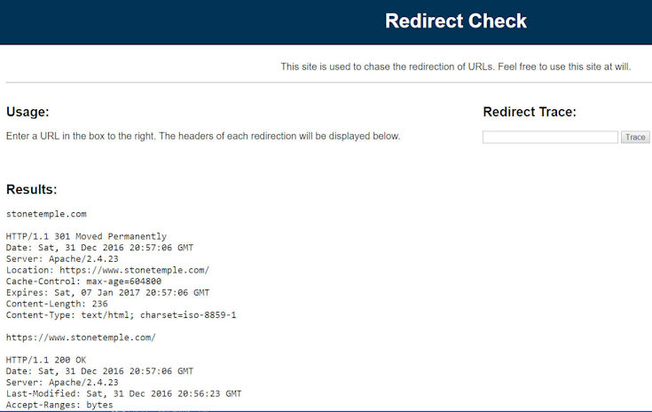

**7. Meta Tags Review**

Each and every web page on a site should have unique title tags and meta descriptions tags—the tags that make up the meta information that helps the search engines understand what the page is about.  
  
[Tweet “Make sure every page on your site has unique title and description tags. Learn more at”]  
  
This gives the website the ability to suggest to the search engines what text to use as the [description of its pages in the search results](https://support.google.com/webmasters/answer/35624?hl=en)(versus search engines like Google generating an “autosnippet,” which may not be as optimal).  
  
It may also help avoid some pages of the website from being filtered out of the search results if search engines use the meta information to help detect duplicate content.  
  
You’ll also want to take this opportunity to check for a [robots metatag](https://developers.google.com/webmasters/control-crawl-index/docs/robots_meta_tag) on the pages of the site. If you find one, there could be trouble. For example, an unintentional “noindex” or “nofollow” value could adversely affect your SEO efforts.

**8. Sitemaps and robots.txt Verification**

It’s important to check the XML Sitemap and robots.txt files to make sure they are in good order. Is the XML Sitemap up to date? Is the robots.txt file blocking the crawling of sections of a site that you don’t want it to? You can use a feature in the Google Search Console to test the [robots.txt file](https://support.google.com/webmasters/answer/6062608?hl=en). You can also test and add a [Sitemap file](https://support.google.com/webmasters/answer/156184?hl=en) there as well.

**9. Image Alt Attributes**

Alt attributes for the images on a website help describe what the image is about. This is helpful for two reasons:

1. I. Search engines cannot “see” image files the way a human would, so they need extra data to understand the content of the image.
2. II. Web users with disabilities, like those who are blind, often use screen-reading software that will help describe the elements on a web page, images being one of them, and these programs make use of the alt attributes.

It doesn’t hurt to use keyword-rich descriptions in the attributes and file names when it’s relevant to the actual image, but you should never keyword-stuff.

**10. Mobile Friendliness**

The amount of people that are searching and purchasing on their mobile devices is growing each year. At Perficient Digital, we have clients who get more than 70 percent of their traffic from mobile devices. Google has seen this coming for a long time, and has been pushing for websites to become mobile friendly for years.  
  
Because the mobile device is such a key player in search today, at the time of writing, Google has declared it will have a [mobile-first index](http://searchengineland.com/faq-google-mobile-first-index-262751). What that means is that it will rank search results based on the mobile version of a website first, even for desktop users.  
  
One key aspect of a mobile-first strategy from Google is that its primary crawl will be of the mobile version of a website, and that means Google will be using the mobile crawl to discover pages on a site.  
  
Most companies have built their desktop site to aid Google in discovering content, and their mobile site purely from a UX perspective. As a result, the crawl of a mobile site might be quite poor from a content discovery perspective.  
  
Make sure to include a crawl of the mobile site as a key part of any audit of a site. Then compare the mobile crawl results with the crawl of the desktop site.  
  
[Tweet “It is now essential for an SEO audit to include a mobile crawl of your site. Find out why at”]  
  
If a website doesn’t have a mobile version, Google has said it will still crawl and rank the desktop version; however, not having mobile-friendly content means a website may not rank as well in the search results.  
  
While there are a few different technical approaches to creating a mobile-friendly website, Google has recommended that websites use [responsive design](https://developers.google.com/webmasters/mobile-sites/mobile-seo/). There’s plenty of documentation on how to do that coming directly from Google, as well as tools that can help gauge a website’s mobile experience, [like this one](https://search.google.com/search-console/mobile-friendly).  
  
It’s worth mentioning Google’s [accelerated mobile pages (AMP)](http://searchengineland.com/amp-breaks-news-main-google-search-results-254965) here as well. This effort by Google is to give website publishers the ability to make their web content even faster to users.  
  
While Google has said that AMP pages won’t receive a boost in ranking at the time of writing, page speed is, however, a signal. The complexity of the technical implementation of AMP pages is one of the reasons some may choose not to explore it.  
  
Another way to create mobile experiences is via [progressive web apps](https://developers.google.com/web/progressive-web-apps/), which is an up-and-coming way to provide mobile app-like experiences on the web via the browser (without having to download an app).  
  
The main benefit is the ability to access specific parts of a website in a way similar to what traditional apps can.

**11. Site Speed**

[Site speed is one of the signals](https://webmasters.googleblog.com/2010/04/using-site-speed-in-web-search-ranking.html) in Google’s ranking algorithm. Slow load times can cause the crawling and indexing of a site to be slower, and can increase bounce rates on a website.  
  
Historically, this has only been a ranking factor when site speeds were *very* slow, but Google has been making noise that it will become more important over time. Google’s John Mueller has also indicated that a site that is too slow, and which is nominally mobile-friendly, may now be deemed as [non-mobile friendly](https://www.seroundtable.com/google-slow-pages-not-mobile-friendly-23203.html). However, currently, mobile-age speed is not currently treated by Google as a ranking factor.  
  
[Tweet “Site speed will become increasingly important as a search factor. Are you ready?”]  
  
In fact, site speed has become such an important element of the overall user experience, especially in mobile, that Google has said it wants above-the-fold content for mobile users to render in [one second or less](https://developers.google.com/speed/docs/insights/mobile).  
  
To help people get more visibility into site speed, Google offers tools such as the [PageSpeed Insights tool](https://developers.google.com/speed/pagespeed/insights/) and the site speed reports found in [Google Analytics](https://support.google.com/analytics/answer/1205784?hl=en).

**12. Links**

Here, we’re looking at links in a couple different ways: internal links (those on the website itself) and external links (other sites linking to the website).  
  
**Internal Links**First, look for pages that have excessive links. You may want to minimize those. Second, make sure the web pages use anchor text intelligently without abusing it or it could look spammy to search engines. For example, if you have a link to the home page in the global navigation, call it “Home” instead of picking your juiciest keyword.  
  
Internal links are what define the overall hierarchy of a site. The site might, for example, look like this:  
  
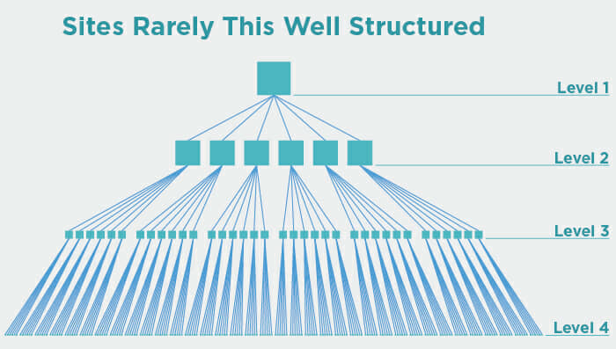

The site above obviously has a well-defined structure, and that’s good. But in practice, sites rarely look like this, and some level of deviation from this is perfectly fine.

A home page may link directly to some of the company’s top products, as shown in Level 4 of the image, and that’s fine. However, it’s a problem if the site has a highly convoluted structure that has many pages that can only be reached after a large number of clicks if you try to navigate to them from the home page, or if each page is linking to too many other pages.  
  
Look for these types of issues and try to resolve them to create something with a cleaner hierarchy.  
  
[Tweet “Make sure your site has a clean internal link structure. Learn more at”]

**External links**  
  
Also known as inbound links or backlinks, you’ll want to perform an analysis to ensure there aren’t any problems there, like a history of purchased links, irrelevant links, and links that look spammy.  
  
You can use tools like [Open Site Explorer](https://moz.com/researchtools/ose/), [Majestic SEO](https://majestic.com/), [Ahrefs Site Explorer](https://ahrefs.com/), [SEMRush](https://www.semrush.com/), and the Google Search Console/Bing Webmaster Tools accounts to collect data about links.

Personally, I like to use all of these sources, collect all of their output data, dedupe it and build one master list. None of the tools provides a complete list, so using them all will get you the best possible picture.

Look for patterns in the anchor text, like if too many of the links have a critical keyword for the site in them. Unless the critical keyword happens to also be the name of the company, this is a sure sign of trouble.

Also, check that there are links to pages other than the home page. Too many of these are another sure sign of trouble in the backlink profile. Lastly, check how the backlink profile for the site compares to the backlink profiles of its major competitors.

Make sure that there are enough external links to the site, and that there are enough high-quality links in the mix.

**13. Subdomains**

Historically, it’s been believed that subdomains do not benefit from the primary domain’s full trust and link authority. This was largely due to the fact that a subdomain could be under the control of a different party, and therefore in the search engine’s eyes, it needed to be separately evaluated.

For an example of a domain that allows third parties to operate subdomains of their site, consider Blogger.com, that allows people to set up their own blogs and operate them as subdomains of Blogspot.com.

For the most part, this is not really true today, and search engines are extremely good at recognizing whether or not the subdomain really is a part of the main domain, or if it’s independently operated.  
  
I still recommend using a subfolder over a subdomain as the default approach to adding new categories of content to a site., However, if you already have it on a subdomain, I would *not* move it to a subfolder unless you have clear evidence of a problem, as there is a cost to site moves, and the upside of making the move is not enough to pay that cost.

[Tweet “You should prefer subfolders over subdomains when structuring a new site. Find out why at”]  
  
For purposes of an audit, you need to make sure you include subdomains within the audit. As part of this, make sure your crawl covers them, and check analytics data to see if there is any clear evidence of a problem, such as it’s getting very little traffic, or recent material traffic drops.

For more on subdomains and their effect on SEO, see [Everything You Need to Know About Subfolders, Subdomains, and Microsites for SEO](https://www.stonetemple.com/subfolders-subdomains-microsites-and-seo/).

**14. Geolocation**

For websites that aim to rank locally, for example, a chiropractor that’s established in San Francisco and wants to be found for “San Francisco chiropractor,” you’ll want to consider things like making sure the business address is on every page of the site, and claiming and ensuring the validity of the Google Places listings.

Beyond local businesses, websites that target specific countries or multiple countries with multiple languages have a whole host of best practice considerations to contend with.  
  
These include things like understanding how to use hreflang tags properly, and attracting attention (such as links) from within each country where products and services are sold by the business.

**15. Code Quality**

A website with clean code that allows the search engines to crawl it with ease enhances the experience for the crawlers. [W3C validation](http://validator.w3.org/) is the “gold standard” for performing a checkup on the website’s code, but is not really required from an SEO perspective (if search engines punished sites for poor coding practices, there might not be much left to show in the search results). Nonetheless, clean coding improves the maintainability of a site, and reduces the chances of errors (including SEO errors) creeping into the site.

**Q-3[A]ONE MARK:**

1]SIFR stand for- Scalable Inman Flash Replacement

2]XML sitemap will be uploaded in-root directory

3]what is microsites?

a. A **microsite** is a brand-specific website (or a single web page) that companies use to promote their individual products, events, or campaigns. These are hosted on their own domain or company's subdomain and have a different URL than their company websites.

4]what is frames?

a. Frames can be laid down in HTML code to create clear structures for a website's content. Search engines often encounter problems when trying to collect content from frames. To make it easier for search engines to find you it is best to avoid using frames.

**Q-3[B]TWO MARK:**

1]what are good and bad redirects?

a.

2]when use sub domain and subfolder?

A. A subdomain is a division or alias of your domain that can be used to organize your existing website into a separate site.

Subfolder:

**Q-3[C]THREE MARK:**

1] expalain robost.txtfile

a. A robots.txt file tells search engine crawlers which pages or files the crawler can or can't request from your site. This is used mainly to avoid overloading your site .

robots.txt is used primarily to manage crawler traffic to your site, and usually to keep a page off Google, depending on the file type:

In short, a Robots.txt file controls how search engines access your website.

This text file contains “directives” which dictate to search engines which pages are to “Allow” and “Disallow” search engine access.

Basic format:

User-agent: [user-agent name]Disallow: [URL string not to be crawled]

• In order to be found, a robots.txt file must be placed in a website’s top-level directory.

• Robots.txt is case sensitive: the file must be named “robots.txt” (not Robots.txt, robots.TXT, or otherwise).

• Some user agents (robots) may choose to ignore your robots.txt file. This is especially common with more nefarious crawlers like malware robots or email address scrapers.

• The /robots.txt file is a publicly available: just add /robots.txt to the end of any root domain to see that website’s directives (if that site has a robots.txt file!). This means that anyone can see what pages you do or don’t want to be crawled, so don’t use them to hide private user information.

• Each subdomain on a root domain uses separate robots.txt files. This means that both blog.example.com and example.com should have their own robots.txt files (at blog.example.com/robots.txt and example.com/robots.txt).

• It’s generally a best practice to indicate the location of any sitemaps associated with this domain at the bottom of the robots.txt file.

Example:

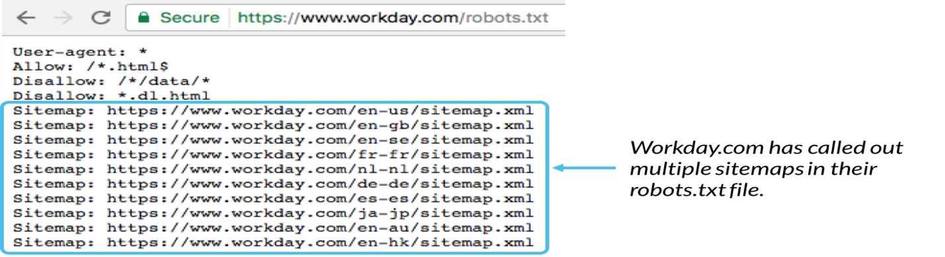

2]difference between flat and deep architecture

a. flat structures possess a horizontal hierarchy while deep architectures possess a vertical hierarchy. ... With flat architecture one can easily access most pages in only a few clicks from the home page. In comparison deep architecture requires more clicks due to the presence of multiple sublevels.

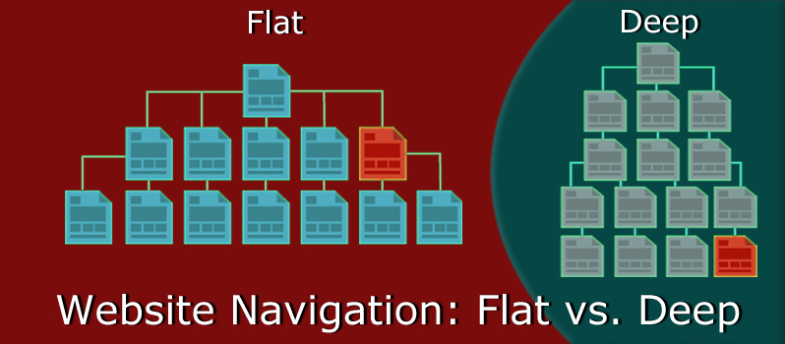

**Q-3[D]FIVE MARKS:**

1]what is sitemap?diffrent types of sitemaps file in detail:

a. A sitemap is a blueprint of your website that help search engines find, crawl and index all of your website's content. Sitemaps also tell search engines which pages on your site are most important. ... It's usually in the form of an XML Sitemap that links to different pages on your website.

**There are two types of sitemaps:**

* HTML Sitemaps
* XML Sitemaps

**XML Sitemaps are further divided into the following types:**

* Image Sitemaps
* Video Sitemaps
* News Sitemaps
* Mobile Sitemaps

**1) HTML Sitemap**

An HTML Sitemap is for the users. It helps visitors navigate across the website easily.

The following is a screenshot of an HTML Sitemap:

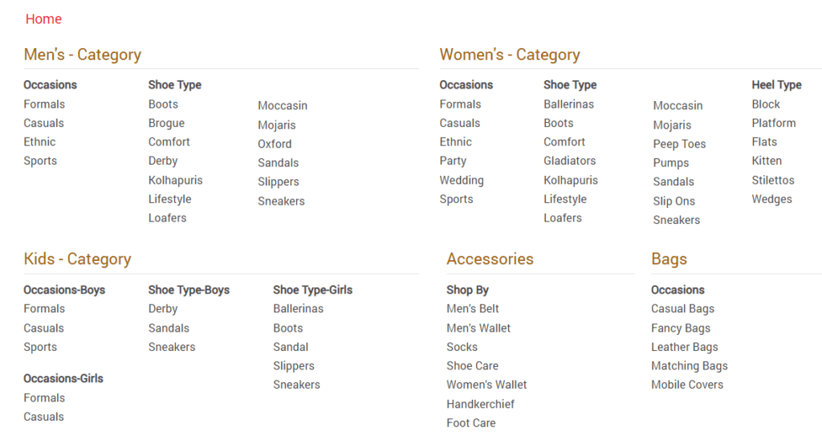

**2) XML Sitemap**

It helps bots to crawl the website in a better way. It also helps them understand which are the most important URLs in a site.

The following is a screenshot of an XML Sitemap:

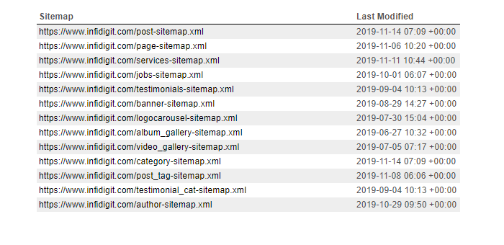

**Types of XML Sitemaps**

**2.1) Image Sitemap:**

* An image sitemap is for images.
* Having an image sitemap helps images get featured in Google Image Search
* <image:image> and <image:loc> tags are mandatory tags for an image sitemap
* <image:caption>, <image:title>, <image:title> and <image: geo_location > are optional tags for an image sitemap
* The following is a screenshot of an image sitemap:

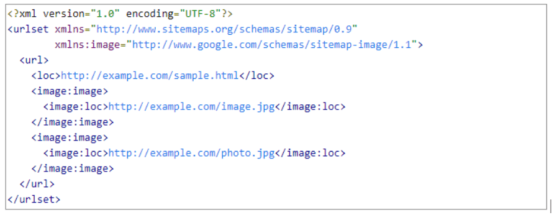

**2.2) Video Sitemap:**

* Similar to the Image Sitemap, a Video Sitemap helps videos get featured in SERPs
* It helps bots better understand video content
* <url>, <loc>, <video:video>, <video:thumbnail_loc>, <video:title>, <video:description>, <video:content_loc> and <video:player_loc> are mandatory tags for a video sitemap
* Here is a screenshot of  Video Sitemap

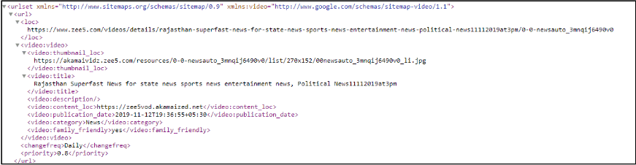

**2.3) News Sitemap:**

* + This sitemap is compulsory for news websites
  + News Sitemaps cannot contain articles which are published more than 2 days priorly
  + News Sitemaps cannot contain more than 1000 URLs
  + If there are more than 1000 URLs, break these URLs into multiple sitemaps and use a [sitemap index file](https://support.google.com/webmasters/answer/71453)
* Having a news sitemap helps articles get featured in the “News Section” of Google SERPs

**2.4) Mobile Sitemap:**

* According to John Muller, there is no need for Mobile Sitemap for a mobile-friendly website
* A Mobile Sitemap is only required if you have a specially formatted version designed for mobile devices

2]list out the places that can be used for keyword targeting?

a.

**Q-4[A]ONE MARK:**

1]what is keyword reserch?

a. Keyword research is a core SEO task that involves identifying popular words and phrases people enter into search engines -make in an attempt to figure out what to rank for.

2]what is short tail keyword?

a. Short-tail keywords are much more general search queries consisting of one or two words, while long-tail keywords consist of three to five or even more words.

3]what is sticky post?

a. A “sticky” post is one that always appears at the top regardless of the date/time posted. The “sticky” feature is available in some blog systems by default (e.g. Blogger.com) and in others through the use of a plugin (e.g. the Adhesive plugin for WordPress).

4]what is local guide?

a. Local Guides is a global community of explorers who write reviews, share photos, answer questions, add or edit places, and check facts on Google Maps. Millions of people rely on contributions like yours to decide where to go and what to do.

**Q-4[B]TWO MARK:**

1]different types of testing technique

a.

2]blog optimization

a.

**Q-4[C]THREE MARK:**

1]long tail keyword demand in detail

a. Long tail keywords are those three and four keyword phrases which are very, very specific to whatever you are selling. You see, whenever a customer uses a highly specific search phrase, they tend to be looking for exactly what they are actually going to buy. In virtually every case, such very specific searches are far more likely to convert to sales than general generic searches that tend to be geared more toward the type of research that consumers typically do prior to making a buying decision.

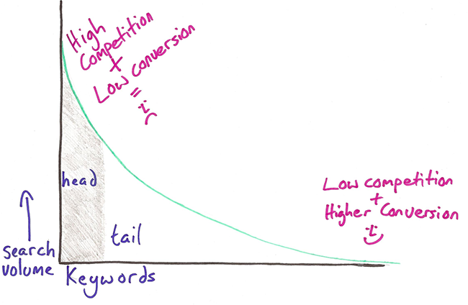

Long tail keywords graph.

To help illustrate this phenomenon, let's take a look at the typical step-by-step buying path that a customer travels on the way to a making a purchase.

Consumer becomes aware of a product.

Consumer seeks information about that product in preparation for possible purchase.

Consumer evaluates alternatives to product (features, pricing, etc...).

Consumer makes their purchase decision.

Consumer pulls out their credit card and completes the transaction.

Consumer then evaluates the product after buying it and decides if they want to keep or return it.

Using the above six step path to a purchase as our model, you can probably already see that you want to target the consumer who is somewhere around step four...

Consumer makes their purchase decision.

...because once they have made their decision to buy something, that's when they start using very specific search phrases to seek out their target purchase.

2]video search optimization

a.7.18

**Q-4[D]FIVE MARK:**

1]explain any two keyword reserch tool

a.5.10

2]explain news,blog,and feed search optimization process in detail

a. . **news:**The news search engines are looking for content that is in the form of either a news story or a feature story. They also are looking to see that you are creating news content in reasonable volume—a minimum of 10 articles per week. News sites are looking for news sources (i.e., sites), not individual news pieces. In addition, as mentioned previously, be aware that both Yahoo! News and Google News very rarely accept new sources. Investing in building a news feed to try to get into these new search engines is an iffy proposition at best, and should only be pursued if you are already committed to producing very high quality news content.

Guidelines for the content are the same as they are for traditional news. The articles should have a catchy, keyword-rich headline and a strong opening paragraph.

The opening paragraph should draw the reader in so that he will read the rest of the article. In traditional news, the main compelling point is put forth at the start, and the discussion continues through other points of descending importance. The news piece should end with a strong concluding paragraph that reviews the major points of the article.

**Blog Optimization**

Blogs are great publishing platforms for those who want to write articles on a regular basis. First, they make it easy to publish the content. Authors only need to log in and use a relatively simple set of menu choices to input what they want to publish, preview it, and then proceed to publish it. It is far easier than coding your own HTML pages by hand.

In fact, it is so easy that entire websites have been built using WordPress as the sole publishing platform. These sites are also typically easy to set up and configure. The world’s most popular blog platform is [WordPress](http://www.wordpress.com/), but the blog platforms from [Moveable Type](http://www.moveabletype.org/) and [TypePad](http://www.typepad.com/) are also popular.

Blogs are inherently social in nature, and a host of social marketing benefits come from blogs. Enabling comments allows for interaction with your readers, and bloggers tend to have a significant level of interaction. For example, one blogger may write a post that reacts to or comments on another blogger’s post. A lot of cross-linking takes place, with one blogger citing another.

Working this aspect of blogging as a social media platform is beyond the scope of this book. Nonetheless, be aware that a blog is an opportunity to establish yourself as an expert in a topic area, and to engage in a give-and-take activity that can dramatically change the visibility of your business.

In addition to these huge benefits, blogs can also bring you search engine and/or blog search engine traffic when they are properly optimized.

## Feed Optimization

Many people mistakenly lump blogs and RSS together, but RSS has infinitely more applications beyond just blogs. RSS feeds can also be used for reporting upon or announcing news alerts, your latest specials, clearance items, upcoming events, new stock arrivals, new articles, new tools and resources, search results, a book’s revision history, top 10 best sellers (as Amazon.com does in many of its product categories), project management activities, forum/listserv posts, and recently added downloads. A good place to start is with basic SEO practices, as we’ve outlined elsewhere in the book (providing good titles and descriptions, handling tracking URLs properly, etc.).

Here are the basics for RSS feed optimization:

* If practical, use the full text of your articles in your feeds, not summaries. A lot of users want to read the full article in the feed without having to click through to your site. This is a case where you need to focus more on the relationship with the user than on immediate financial goals.
* Consider multiple feeds. You can organize them by category, latest comments, comments by post, and so on.
* An RSS feed that contains enclosures (i.e., podcasts) can get into additional RSS directories and engines, as there are many specialized directories just for podcasts or other types of media.
* Make it easy to subscribe. Ideally, users should have to click only once to subscribe via their favorite aggregator. You can do this through “Add to ____” (My Yahoo!, Bloglines, Google Reader, etc.) buttons on your site. Also make sure to implement <link> tags for auto-discovery (e.g., <link rel="alternate" type="application/rss+xml" title="RSS" href="http://feeds.stephanspencer.com/scatterings" />) in the <head> section of your web pages.

**Q-5[A]ONE MARK:**

1]what is blogosphere?

a.

2]what is reputation monitoring?

A. Reputation management is the effort to influence what and how people think of a brand or person when viewed online. ... Either way, you will work to monitor and improve your reputation over time, often starting with improving your search engine results.

3]what is user interaction?

a. One of the factors Google takes into account when deciding the value of a certain website is user interaction. ... The more users interact with a particular website, the more valuable it appears to Google, as it demonstrates user interest.

4]what is voice recognize search?

a. Voice recognize search essentially allows users to speak into a device as opposed to typing keywords into a search query to generate results.

**Q-5[B]TWO MARK:**

1]explain tracking cycle in detail

a. SEO tracking is a critical component of search engine optimization which ... SEO is actually performing, you need to track each step of your sales cycle. ... For example, you can set up one phone number for Google AdWords, ...

* *tracking**cycle:produce,launch,measure,refine*
* *define an seo campaign and set goals*
* *establish a baseline*
* *collect data*
* *compare the baseline data to the new data*
* *discuss our strategy*
* *proceed with your project*
* *refine your compaign*

2]what is crawl efficiency?

a. Crawl efficiency is how seamlessly bots are able to crawl all the pages on your site. A clean site structure, reliable servers, errorless sitemaps and robots. txt files, and optimized site speed all improve crawl efficiency.

**Q-5[C]THREE MARK:**

1]explain project ROI in detail

a.

2]mobile search?

A.7.17

**Q-5[D]FIVE MARK:**

1]what is action tracking? explain action tracking activities.

a. Action Tracking is a method of logging progress on internet that is a cookie-based method to track actions and page visits.

2]how search engine expert would servive increased market saturation and completion?

A. 9.9